JavaScript Day1 Task

1)Difference between HTTP1.1 vs. HTTP2?

HTTP stands for hypertext transfer protocol, and it is the basis for almost all web applications. More specifically, HTTP is the method computers and servers use to request and send information.

The first usable version of HTTP was created in 1997. Because it went through several stages of development, this first version of HTTP was called HTTP/1.1. This version is still in use on the web. In 2015, a new version of HTTP called HTTP/2 was created.

HTTP/2 solves several problems that the creators of HTTP/1.1 did not anticipate. In particular, HTTP/2 is much faster and more efficient than HTTP/1.1.

| **HTTP/1.1** | **HTTP/2** |
| --- | --- |
| It works on the textual format. | It works on the binary protocol. |
| There is head of line blocking that blocks all the requests behind it until it doesn’t get its all resources. | It allows multiplexing so one TCP connection is required for multiple requests. |
| It uses requests resource Inlining for use getting multiple pages | It uses PUSH frame by server that collects all multiple pages |
| It compresses data by itself. | It uses HPACK for data compression. |

2) Write a blog about objects and its internal representation in JavaScript?

**Object:**

In JavaScript, an object is a standalone entity, with properties and type. Compare it with a cup, for example. A cup is an object, with properties. A cup has a color, a design, weight, a material it is made of, etc. The same way, JavaScript objects can have properties, which define their characteristics.

**Creating Objects in JavaScript:**

1. By object literal
2. By creating instance of Object directly (using new keyword)

**By object literal:**

The syntax of creating object using object literal is given below:

https://miro.medium.com/v2/resize:fit:655/1*BPfZK2NMr7-nsIXYyXNFew.png

Property and value is separated by colon(:).

**Example:**

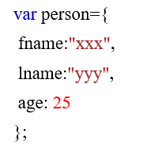

**By creating instance of Object directly (using new keyword):**

The syntax of creating object directly is given below:

https://miro.medium.com/v2/resize:fit:330/1*Cl7DNbx5EPkMmmxMgekUNQ.png

A **new keyword** is used to create object.

**Example:**

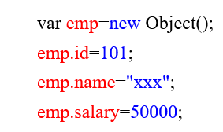

**Accessing JavaScript Objects:**

The syntax for accessing the property of an object is: *objectName.property (or)* *objectName*[“*property*”]

Accessing ‘fname’ from example 1 using dot operator,

https://miro.medium.com/v2/resize:fit:147/1*cRKvllBbiRrpQ6HwyMqgjw.png

Accessing ‘name’ form example 2 using [],

https://miro.medium.com/v2/resize:fit:151/1*PmkEzSlXEcK52EETn8yMoQ.png